Serial Number: 3T9AVTE3E3MS

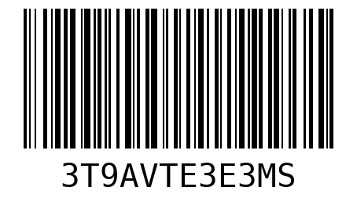

Serial Number: D2205IGRE7HX

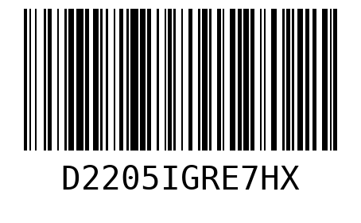

Serial Number: SIS9DS73YEY8

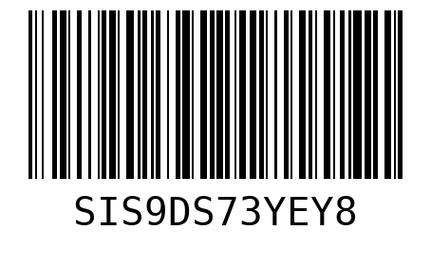

Serial Number: H08RD8ZVFXL2

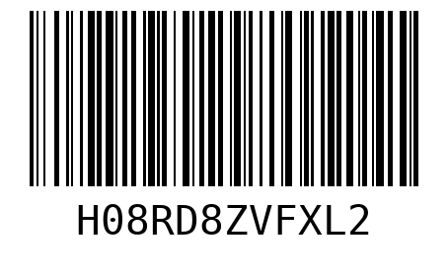

Serial Number: I8VP0GO6MCKQ

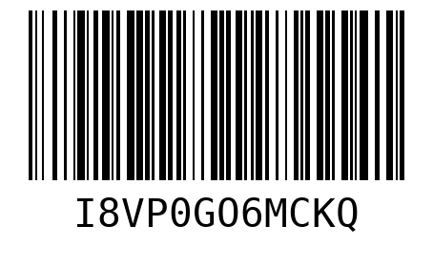

Serial Number: VS2A6KJ80BBY

